Installing JBoss as a windows service

Version 1.01
Date 01/11/10

Revision history

Doc No: | Version no. | Change reference no. | Author | Published date | Sections changed | Description of changes
 | 1.0 |  |  | 01/11/10 |  | Base Document

Purpose of the document 4
Scope of the document 4
Desired outcome 4
Targeted recipient 4
Prerequisite 4
Required Software 5
Need for registering JBoss as a Windows Service 5
Registering a service in Windows 5
Using The JBoss Native Windows Service 5
Configuring JBoss Services 6
Operating JBoss services from Windows Service Manager 7

Purpose of the document

To demonstrate the following

- How to install JBoss Application Server (AS) as a windows service
- How to uninstall JBoss as a service
- Configuring services to pass different parameters at service startup

Scope of the document

This document is all about how to JBoss services and their maintenances for window based systems. It doesn’t cover the following points.

- Installation and configuration of JBoss.
- Operating JBoss Application Server.
- Installation of JBoss service under Linux or other operating systems

Desired outcome

It is expected that after going through this document the reader will be proficient in the following

- Installing/Uninstalling JBoss as Windows Service.
- Configuring JBoss service.

Targeted recipient

- Implementers who will be responsible for installing JBoss at Client side ( It is not necessary to run JBoss as a Window’s service for development environment)

Prerequisite

- Knowledge of JBoss AS.
- Starting/Stopping Windows Service and basic knowledge of windows services.
- Knowledge of batch file editing.

Required Software

Following Softwares are required for this tutorial

- JBoss AS 5.0.1 ( downloadable from http://www.jboss.org/jbossas/downloads.html ).
- JBoss -native-2.0.9-windows-x86-ssl ( downloadable from http://labs.jboss.com/jbossweb/downloads/jboss-native-2-0-9).
- EditPlus (for editing Services batch file).

Need for registering JBoss as a Windows Service

JBoss application server is generally started using the run scripts provided by the application server. Although this is sufficient for development work, in a production environment, you want the application server to come up at the same time the system is started. This can be done by registering JBoss as a Windows Service.

Registering a service in Windows

Windows defines a specific API that must be implemented by an application that wishes to run as a service. Unfortunately, none of the Java executables implement that API. Fortunately, that fact isn’t a problem because Java SE defines a standard API, the Java Native Interface (JNI), that establishes how Java code and C/C++ code interact.

All that’s required to run a Java application as a Windows service is to provide a
simple executable that follows the Windows service API specification and uses the JNI
specification, or some other mechanism, to launch the JVM and the Java application.

Because this is a fairly generic task, the JBoss team already provides such a tool as part of the JBoss Native package, which is part of the JBoss Web project

Using The JBoss Native Windows Service

As mentioned earlier download the JBoss Native Service package. Note that there are several variants, each for a specific OS and CPU type. Make sure you get the one for Windows platform.

Follow the steps mentioned below –

- Unzip the file into some location of your machine.

- This action will create two folder viz. “bin” and “license”.

- Copy “ jbossvc.exe” and folder named “native” under jboss-native-2.0.9-windows-x86-ssl/bin to bin folder of JBoss home

- Go to command prompt → go to Jboss_home/bin folder and type

“service install”.

This will install JBoss as a Windows Service with a message as shown in the below figure
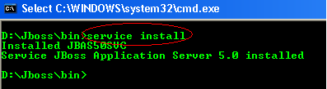

Figure 1 - Installing JBoss Service

- To Uninstall , Go to command prompt → go to Jboss_home/bin folder and type

“service uninstall”.

This will uninstall JBoss as a Windows Service with a message as shown in the below figure

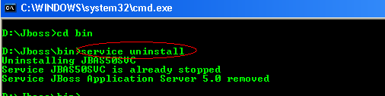

Figure 2 - Uninstalling JBoss Service

Configuring JBoss Services

To configure JBoss service to pass parameters at startup the batch file Service.bat under JBOSS_HOME/bin directory needs to be edited.

To pass parameters for start-up edit the section “:cmdStart” and pass required parameters in the “run” and for shutdown edit the section “:cmdStop” and pass required parameters in the “shutdown”.

For example to start JBoss in networking mode the following command is used “run –b 0.0.0.0”. To pass the same edit the Services.bat file as mentioned below.

- Right click “Services.bat” and click on EditPlus.
- This will open the file in EditPlus
- Go to “:cmdStart” section and go to line “call run.bat”
- Add “-b 0.0.0.0” after it , as shown below

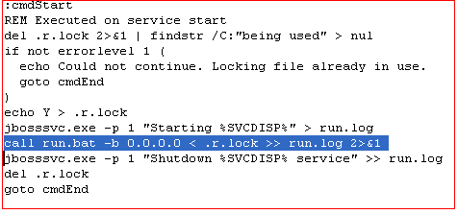

Figure 3 - Editing Services batch file

Operating JBoss services from Windows Service Manager

Once all the installation and required configurations are done then what remains is the knowledge of operating JBoss Services under Windows Services. These are described below

- Go to “Start → Run” in the machine in which JBoss AS is installed as a windows’ service.

- Type “services.msc” and click on “OK” or press “Enter”

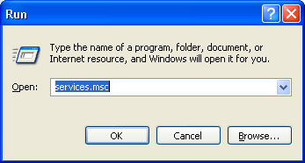

- This will open the windows service manager as shown below

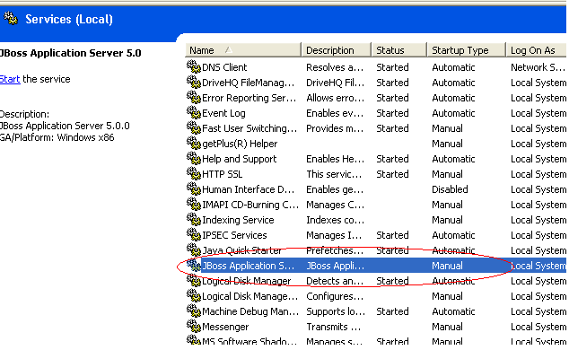

- As shown above, Select the service “JBoss Application Server”

- By default its Startup type is Manual which means that each time it has to be started manually and will not start by default at the time of windows startup

- To start it automatically at the time of windows’ startup “Right Click at JBoss Application Server → Click on Properties” , as shown below
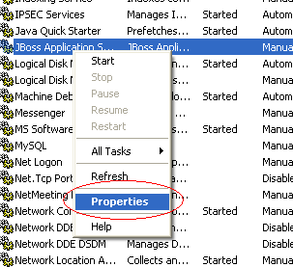

- This will open the properties window as shown below

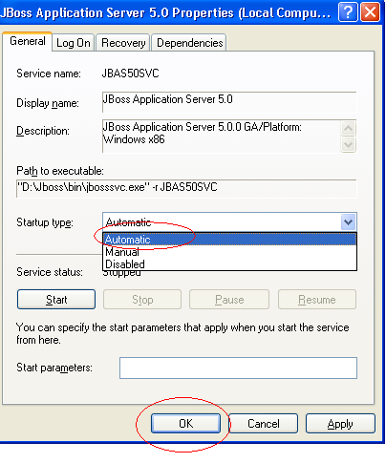

- Change the startup type to “Automatic” and click on “OK”

